## Introduction

The Birch Mini Joystick – A is a small analog gaming joystick that moves in a sliding motion instead of the typical pivoting motion of a joystick or thumbstick. It has a relatively small range of motion and a moderately low force required. It has a 3.5 mm TRRS plug (the size of a headphone jack) and can be used to play games with the Xbox Adaptive Controller (XAC).

## Features

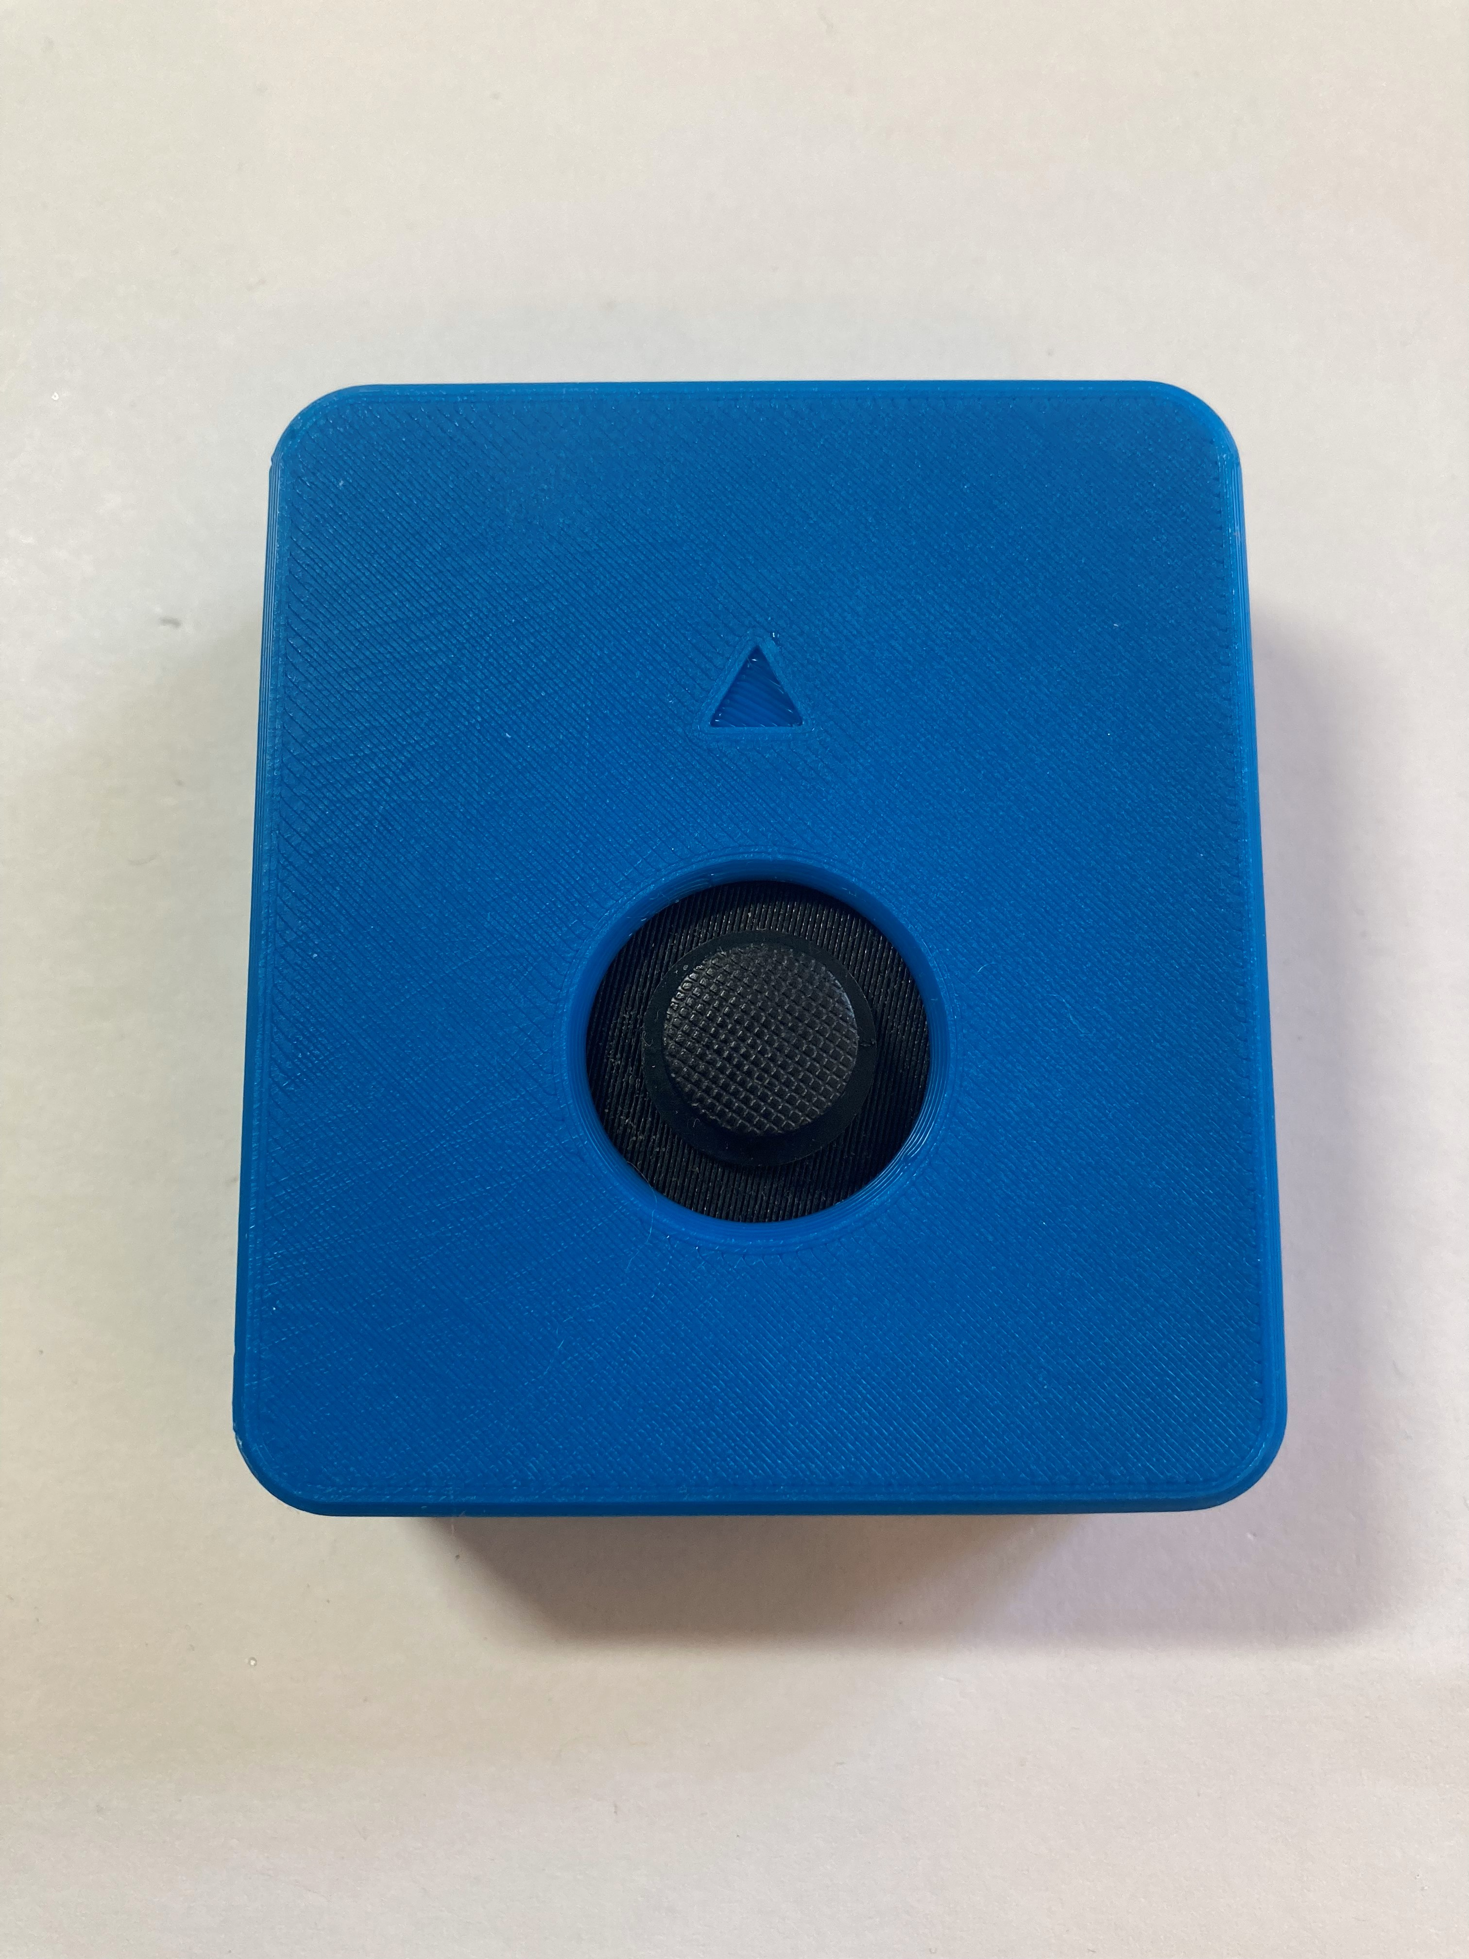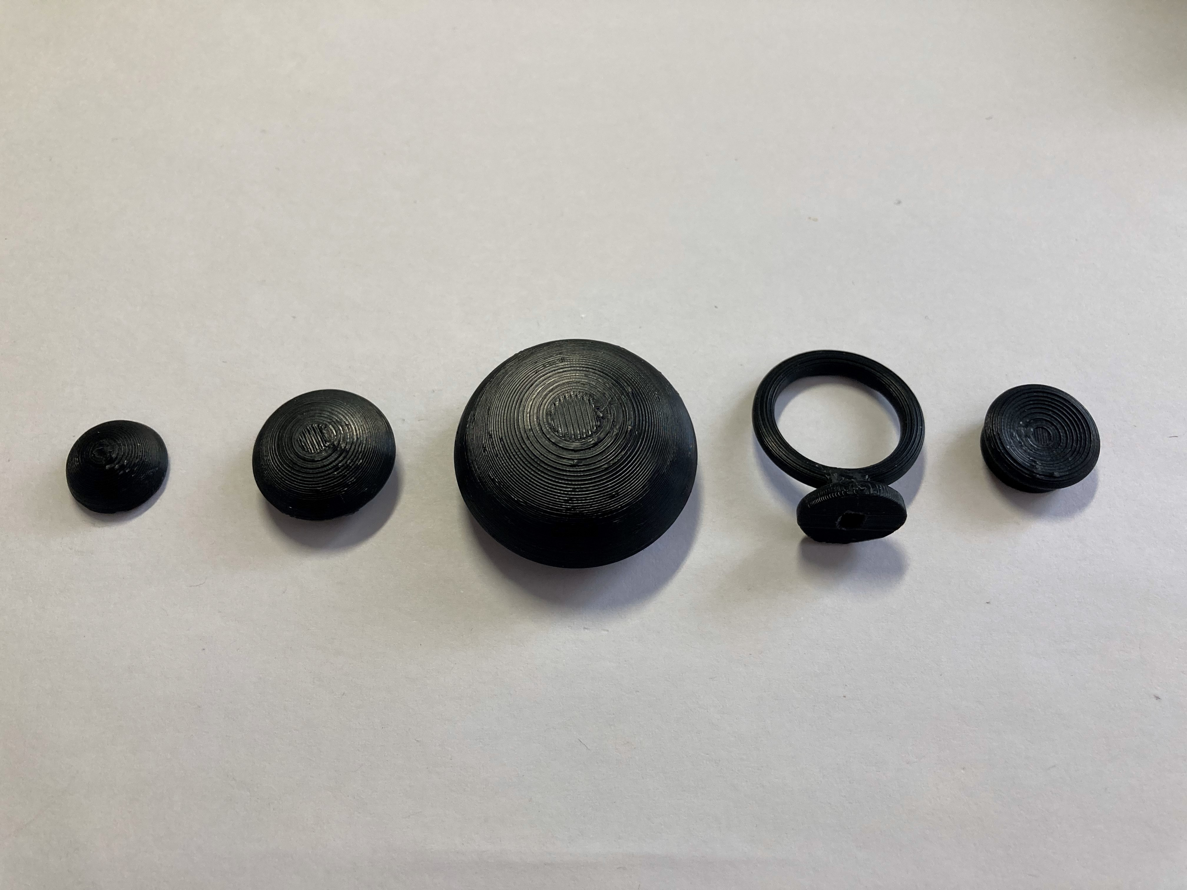

Interchangeable joystick toppers

Arrow indicating “up” direction on joystick

### 3.5 mm TRRS Cable

This is the 3.5 mm TRRS cable that will plug into the gaming controller you are using.

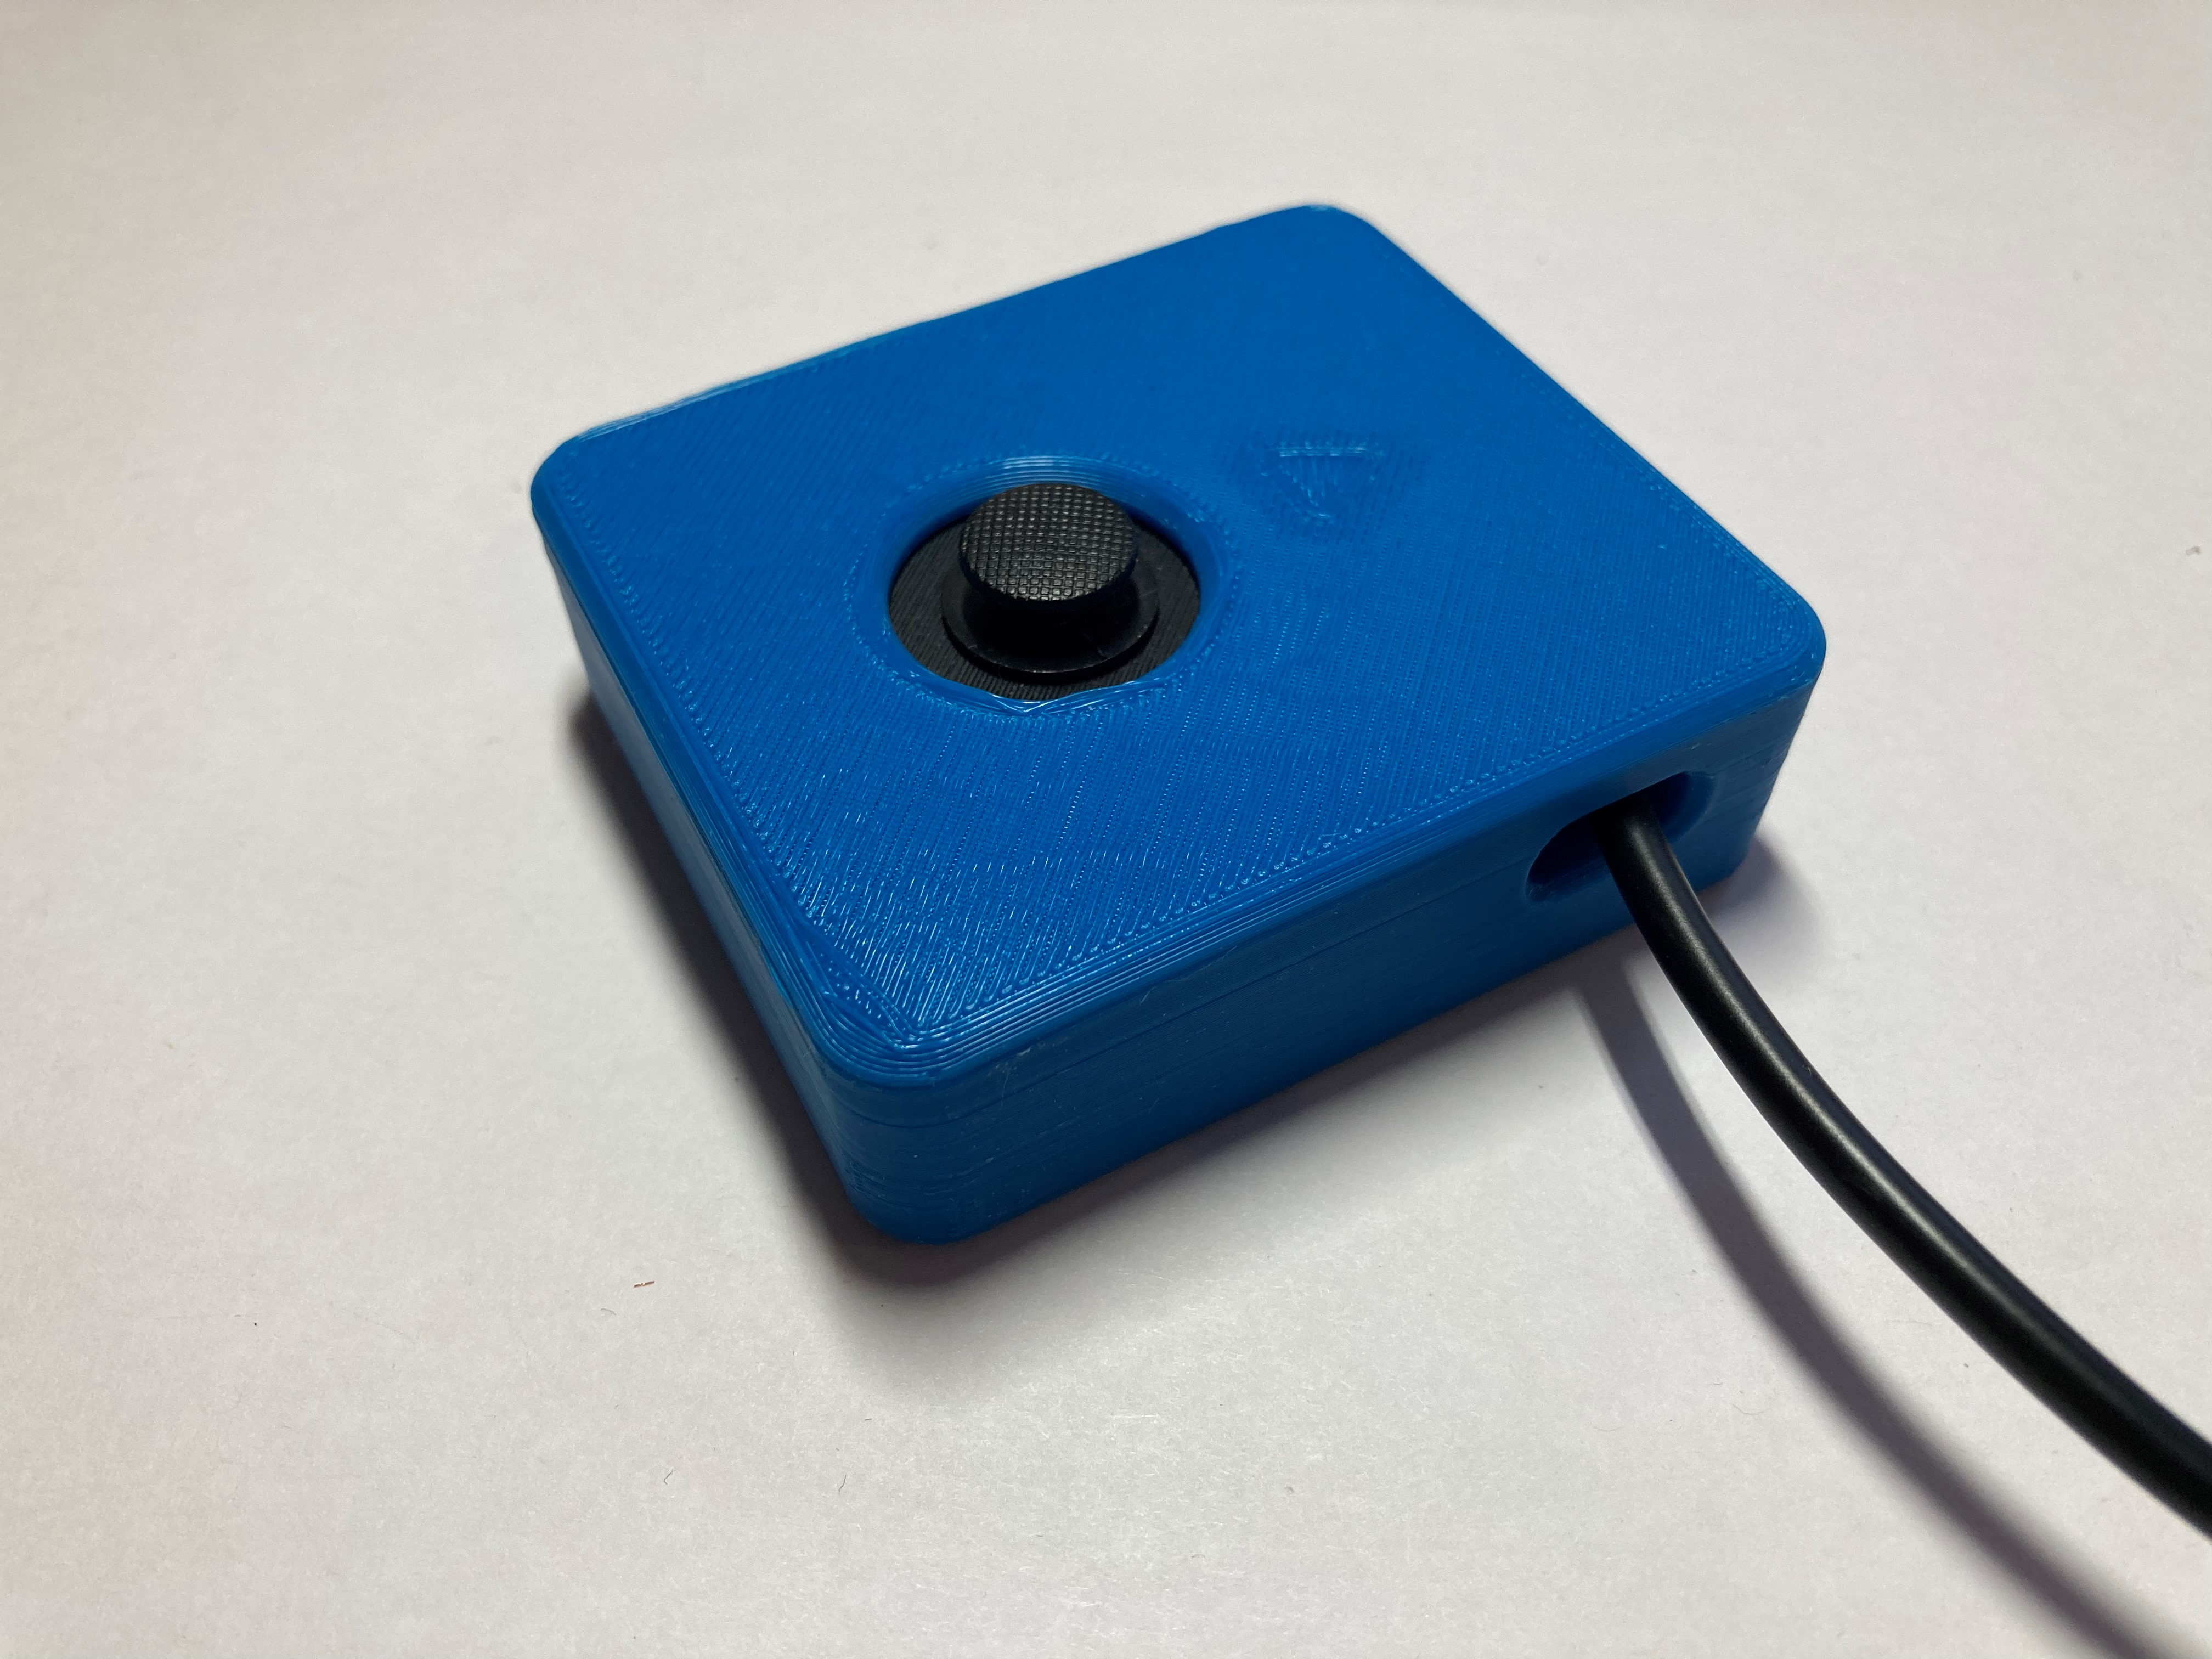

3.5 mm TRRS cable

### Mounting holes

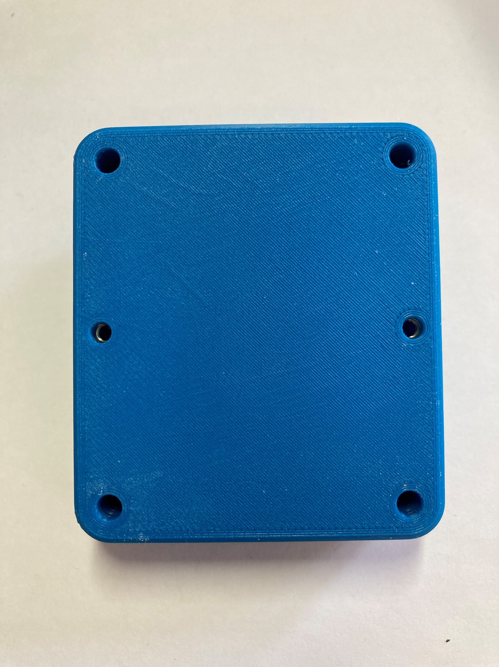

Screw holes for mount adapters

### Joystick Camera Mount Adapter

The Joystick Camera Mount Adapter allows the joystick to be mounted using a ¼-20 thread which is standard for camera mounts.

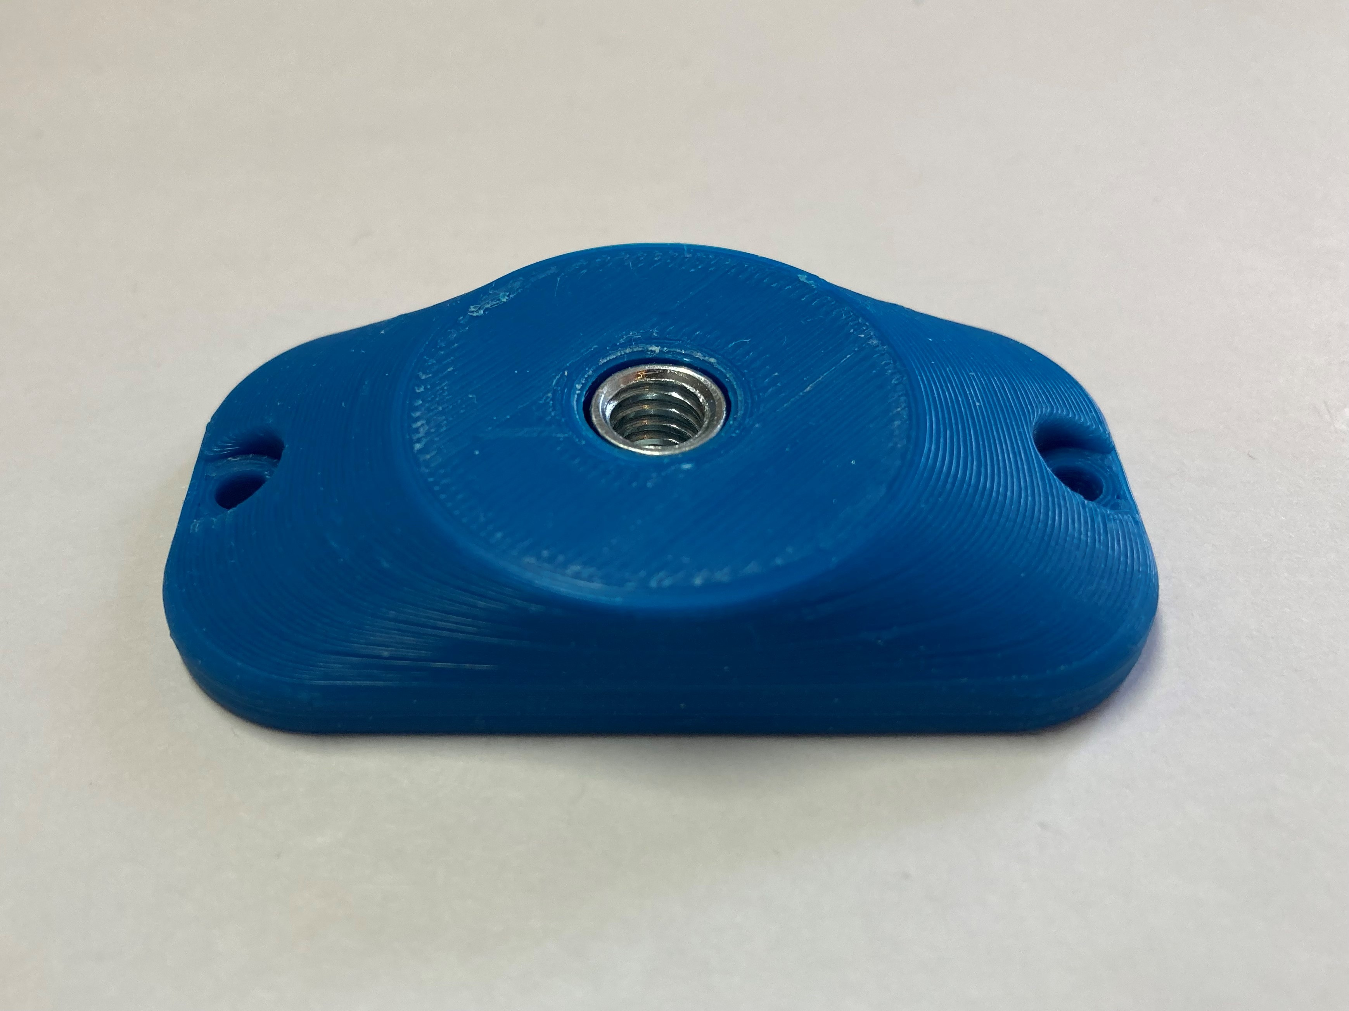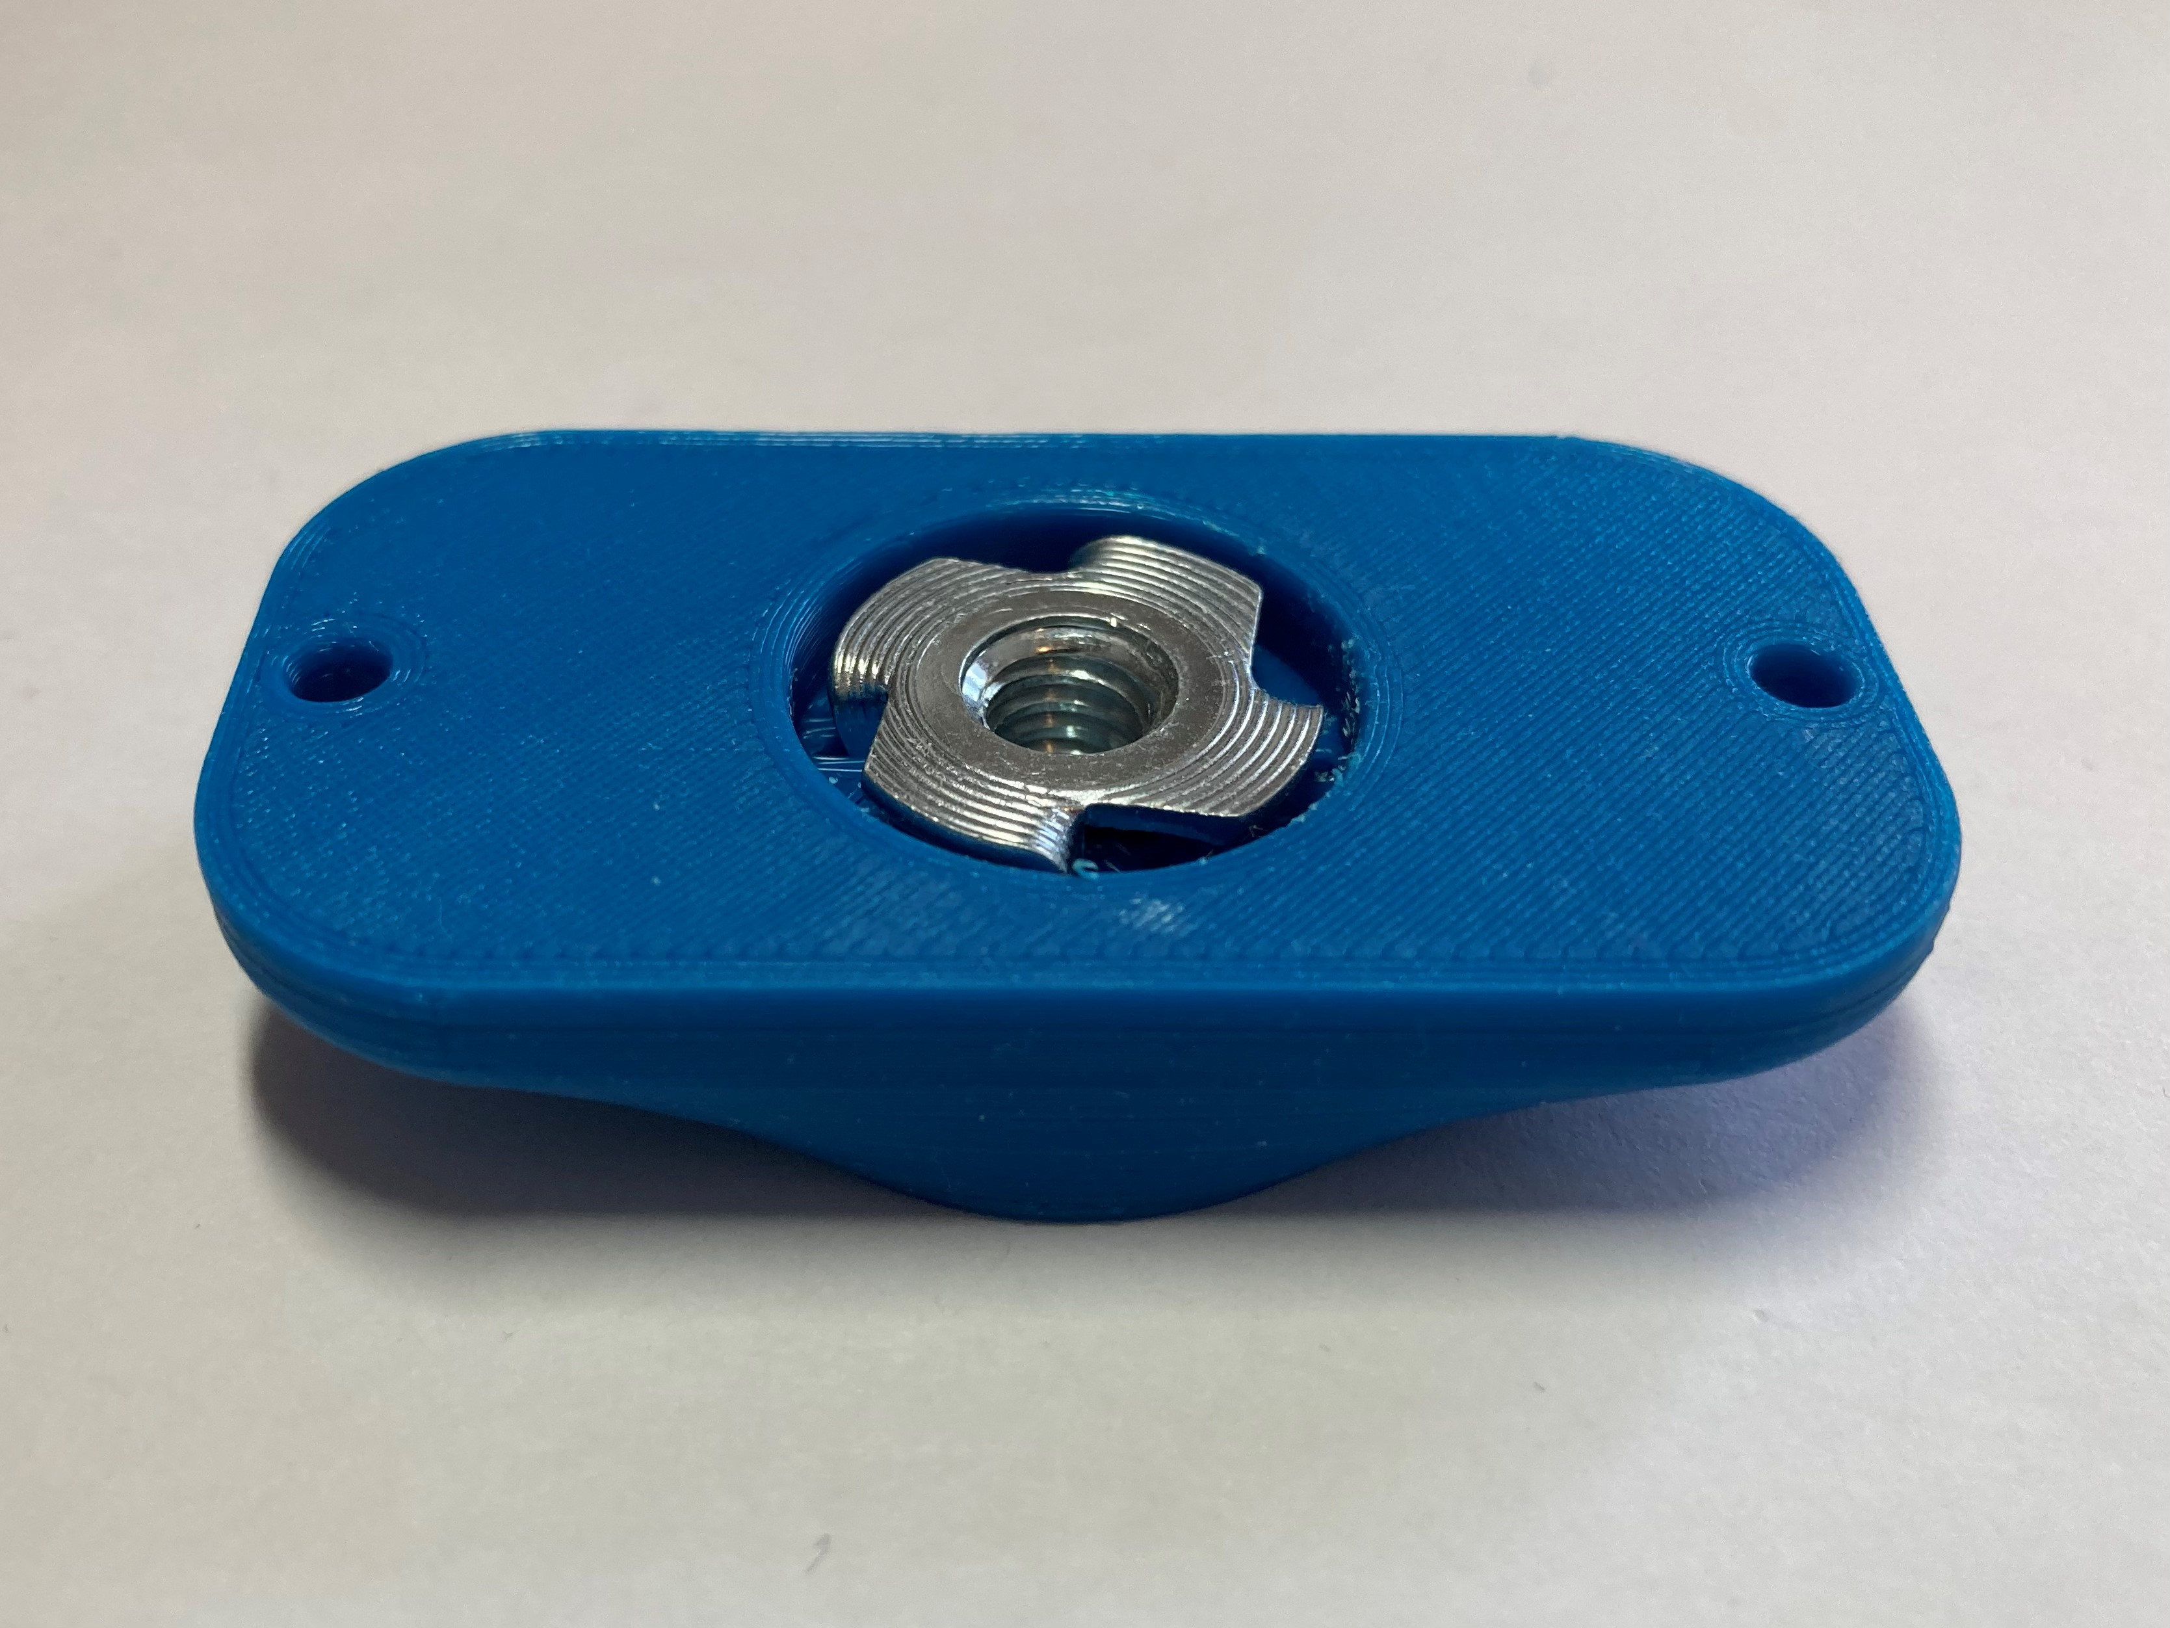

Screw holes to attach to joystick

¼-20 thread for camera mount

## Usage

### Using the Joystick

1. Plug the 3.5 mm TRRS cable from the joystick into the host device (such as the Xbox Adaptive Controller). If using the Xbox Adaptive Controller, plug it into X1 to use at the left joystick, or plug into X2 to use as the right joystick.
2. Ensure the arrow on the joystick is pointing in the “up/forward” direction, away from the user.
3. Mount the device if needed (see below).
4. Move joystick as you would with a standard controller.

### Compatibility

Compatible with the Xbox Adaptive Controller (XAC). May be compatible with other interfaces that use joysticks with 3.5 mm TRRS cables, such as the [Enabled Controller](https://makersmakingchange.com/project/enabled-controller/).

### Changing the Joystick Topper

There are a variety of toppers that can be 3D printed for this joystick, shown below. 

To use them:

1. Remove the original joystick topper by pulling it off, revealing a small peg underneath
2. Take the 3D printed topper, check that it is in the correct orientation and press it onto the joystick. The fit should be snug.

Photos of the toppers on the joystick:

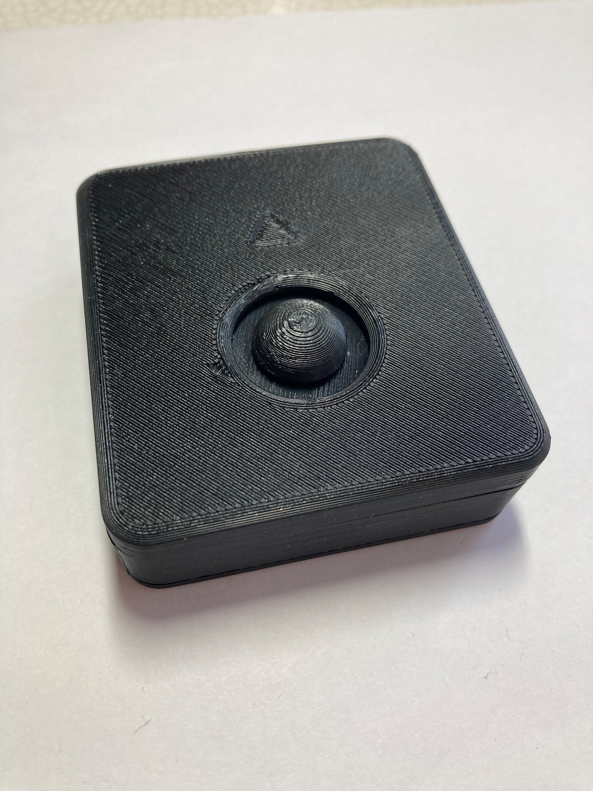 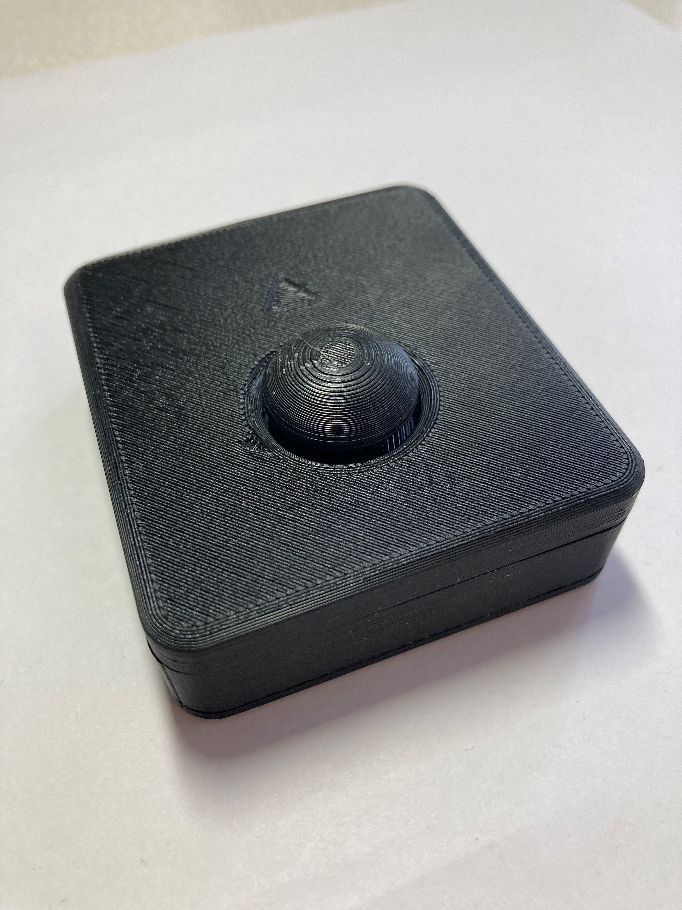

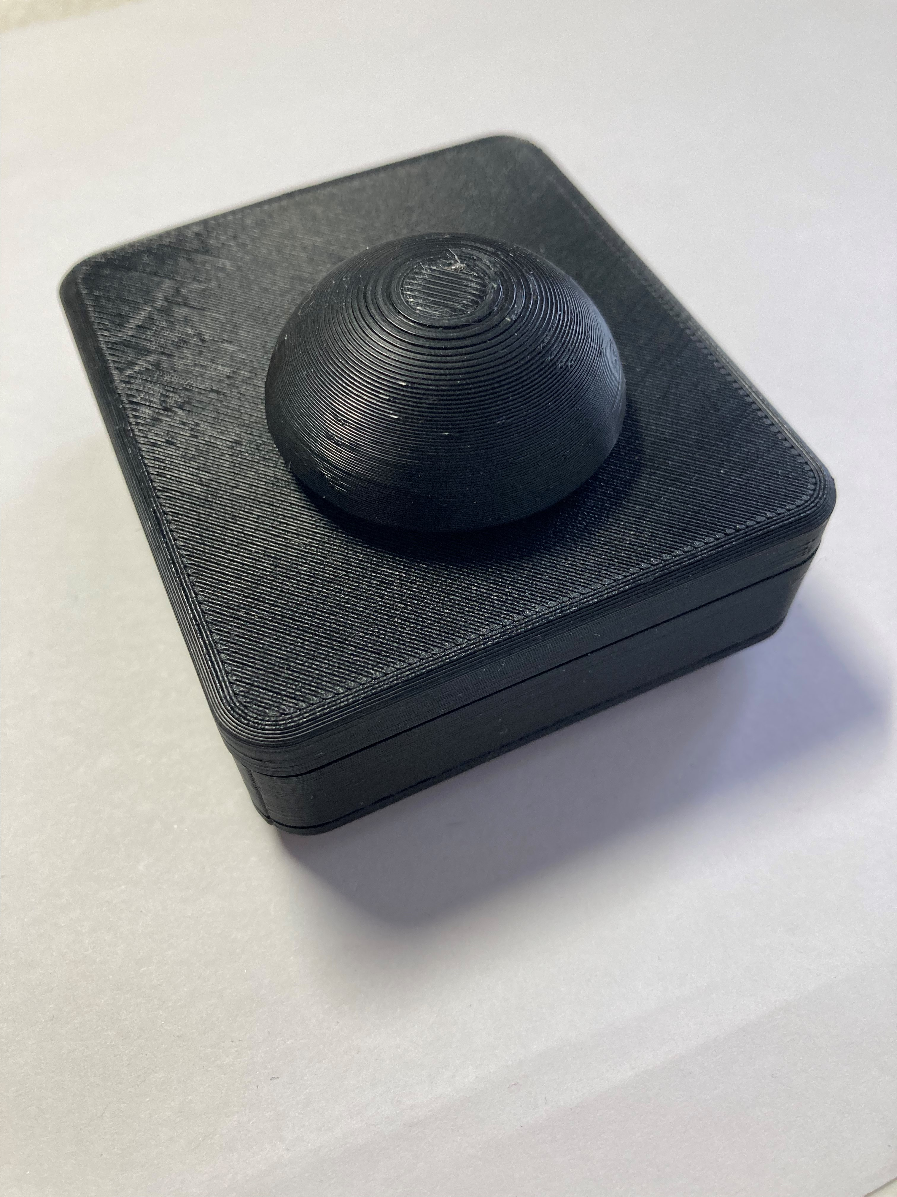 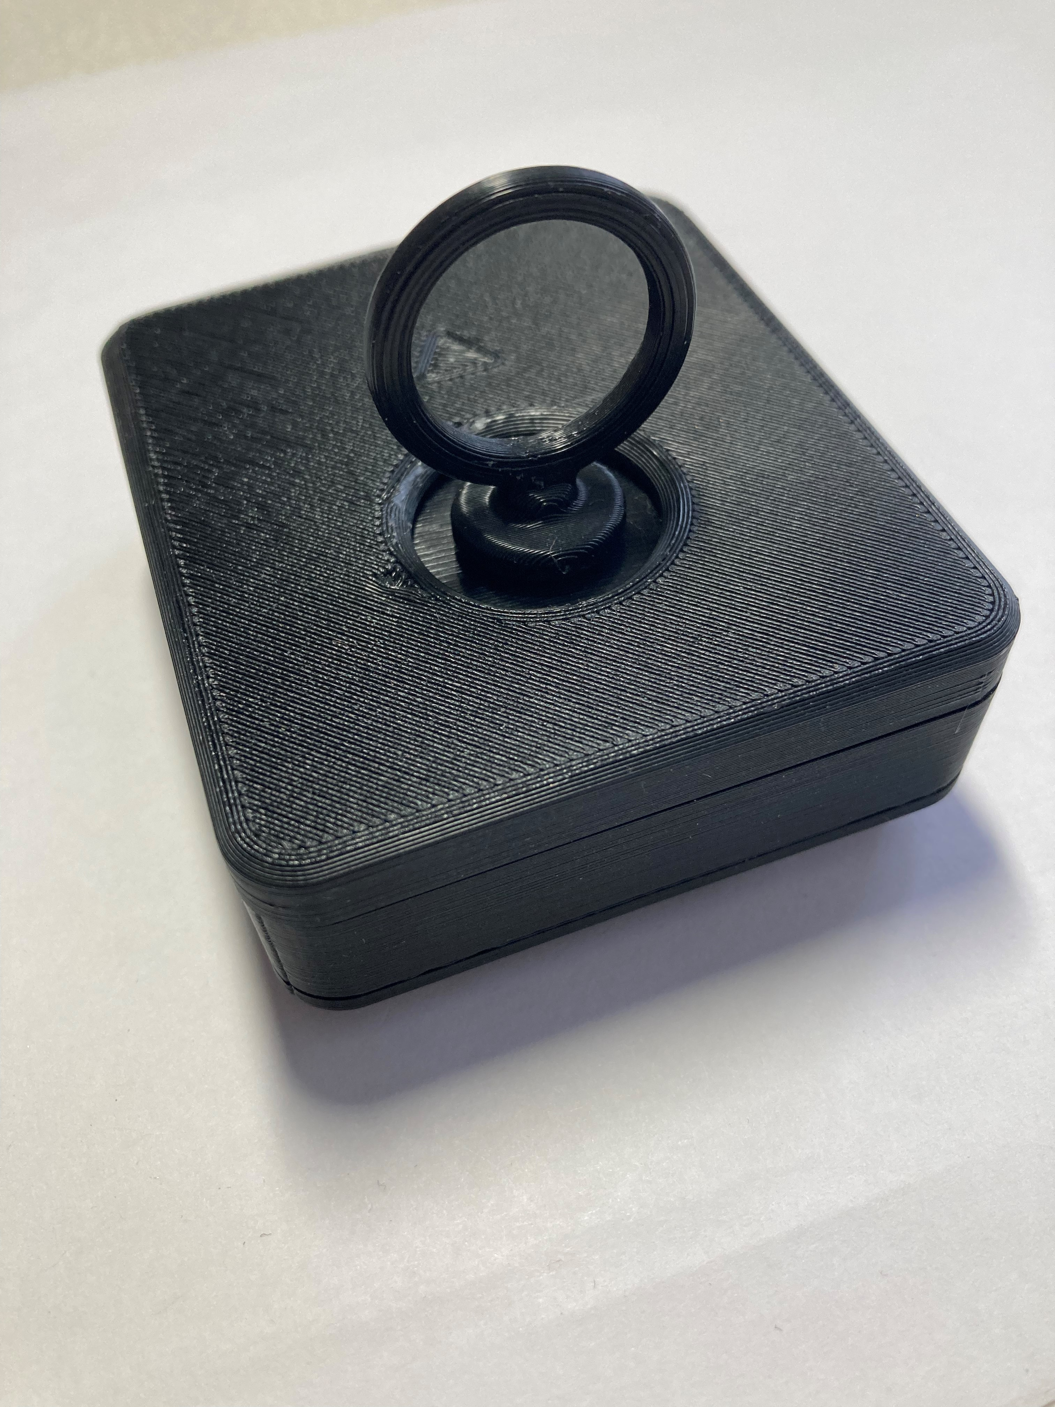

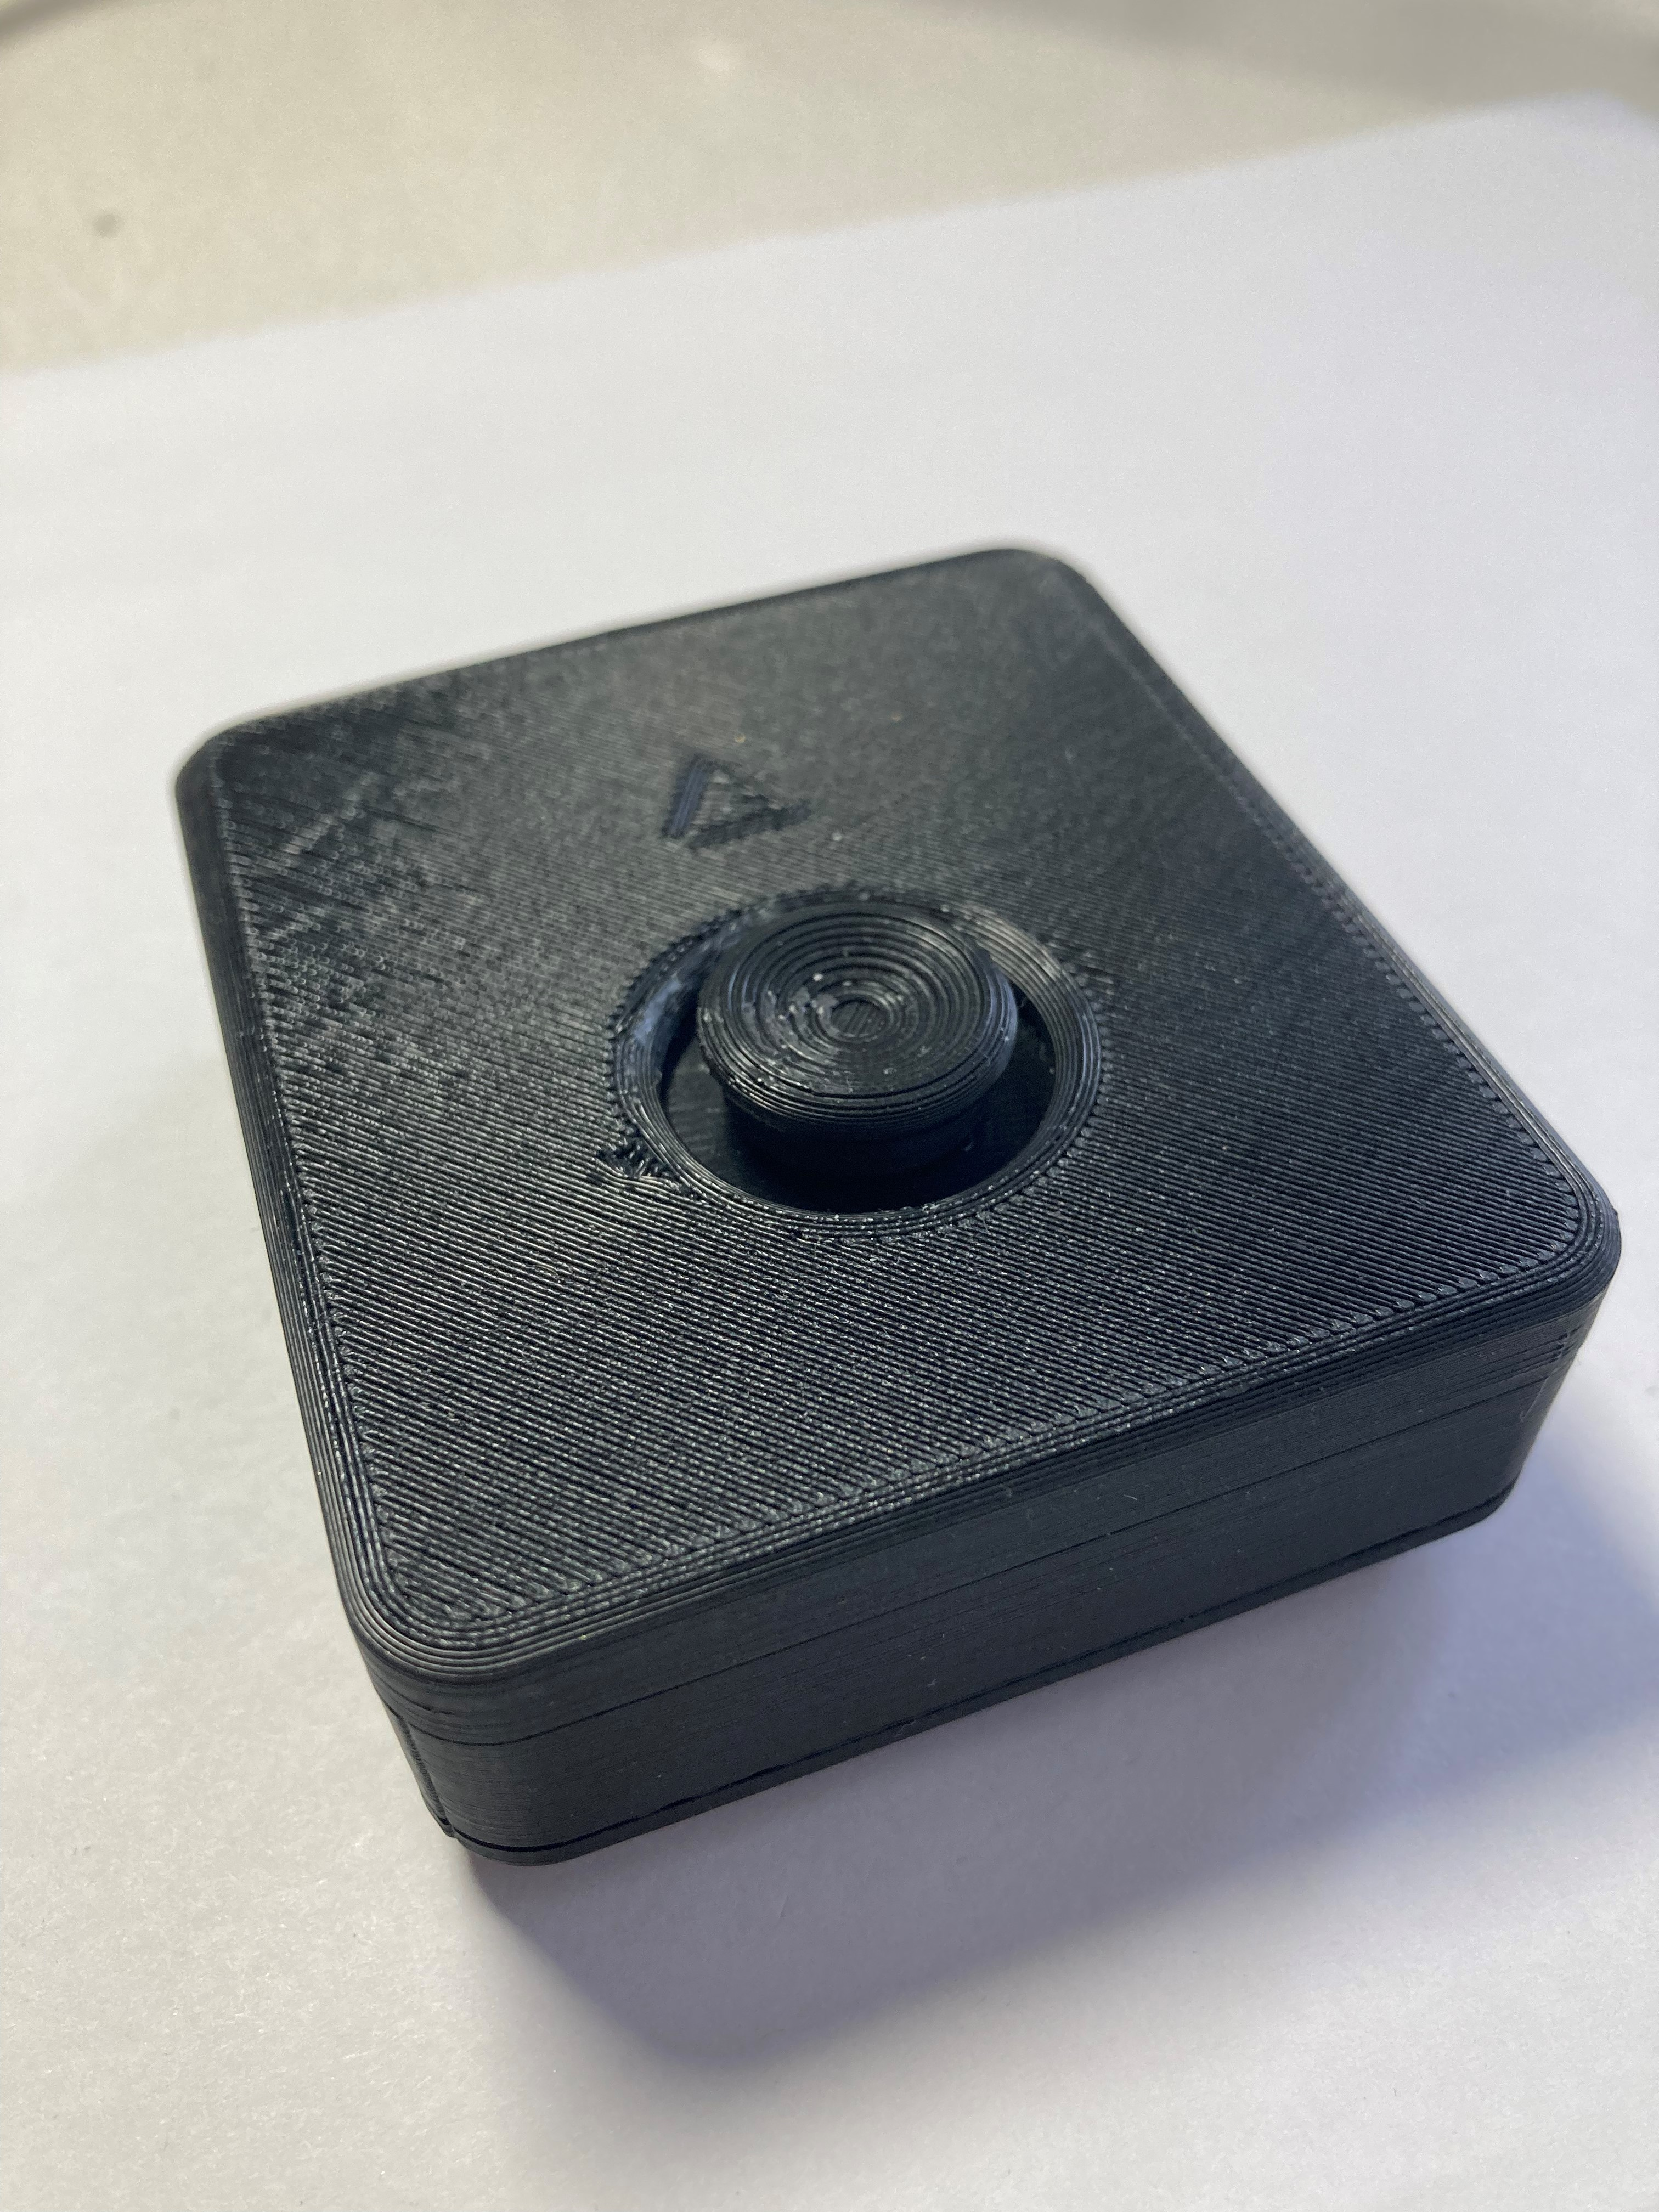

### Mounting the Joystick

#### Tabletop – Hook and Loop Fastener

|  |  |
| --- | --- |
| One way the joystick can be mounted, is on a tabletop or other surface such as a lap tray, and fastened using a hook and loop fastener such as Velcro.  Typically, best practice is to stick the side with the loops (the softer side) to the tabletop or other surface, and to stick the side with the hooks (rough side) to the joystick. | Bottom of the joystick with hook and loop fastener attached to the bottom. The hook side is shown stuck to the joystick. |

#### Tabletop – Non slip pads

Another way the joystick can be use on the tabletop is by using a non slip material, such as the no slip stoppers shown below, or a non slip material such as Dycem.

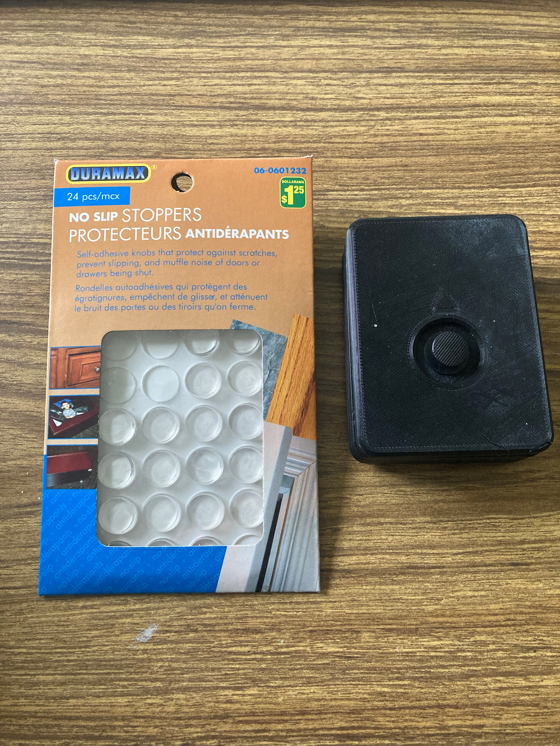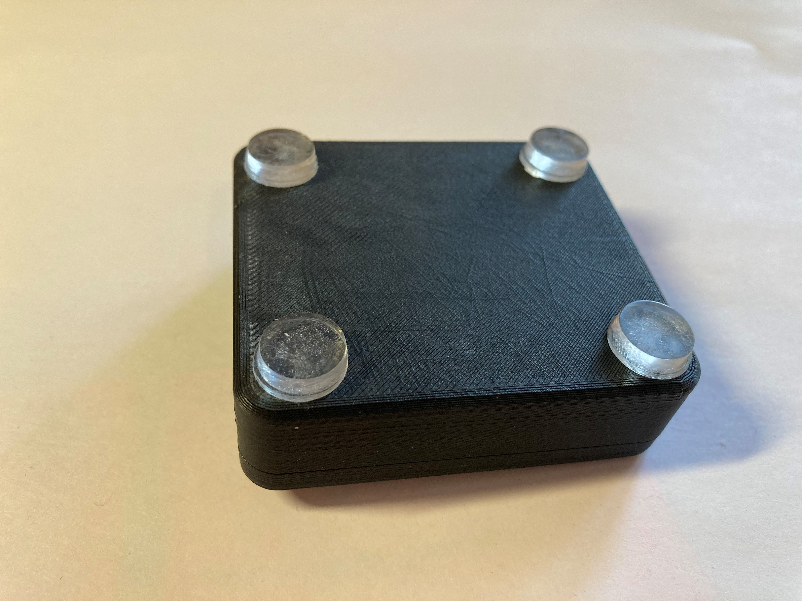

#### ¼-20 Threaded Camera Mount

Another way the joystick can be mounted, is by using a mount with a ¼-20 thread on the end, such as a commercially available camera mount. To mount the joystick on a ¼-20 thread, the Camera Mount Adapter is used. The assembly for this Camera Mount Adapter is found in the Assembly Guide.

Camera Mount Adapter:



This is then screwed onto the bottom of the joystick, as shown below, using two M3 screws that are at least 10 mm long. Now, the joystick can be mounted on a mount with ¼-20 thread, such as a typical camera mount.

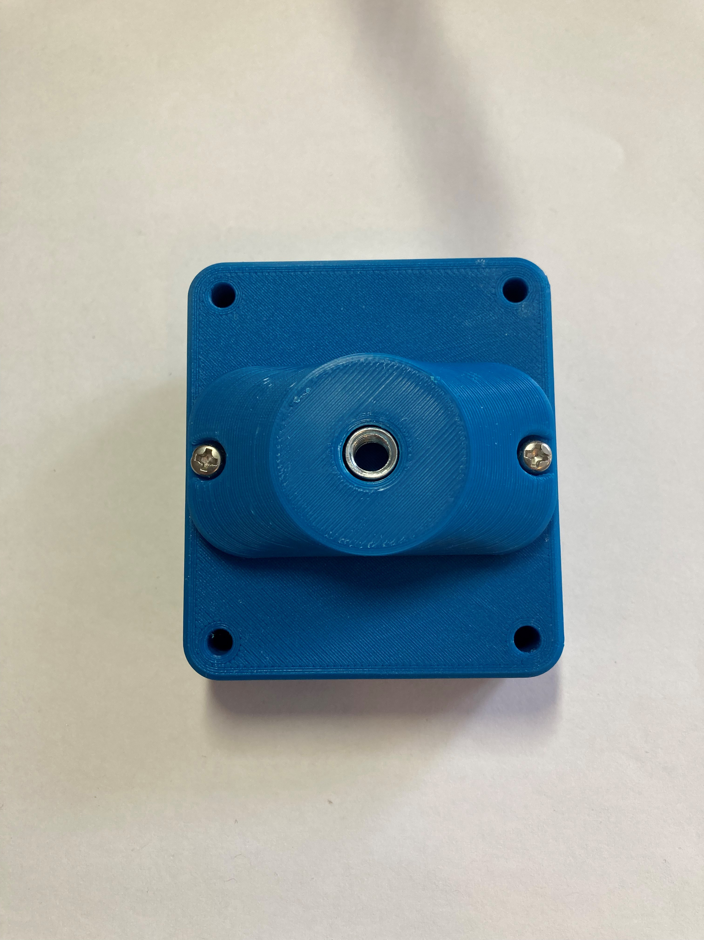

## Specifications

|  |  |
| --- | --- |
| Total height (with default topper) | 2.4 cm |
| Enclosure height | 2.1 cm |
| Enclosure width | 6.0 cm |
| Enclosure length | 6.8 cm |
| Weight (including TRRS cable) | 60 grams |
| Range of motion | ±2 mm |
| Activation force (to full deflection) | 115 grams of force |

## Cleaning

The Birch Mini Joystick can be wiped down with a damp cloth. Do not use hot water on this device or the plastic housing may warp. Do not submerge the device.